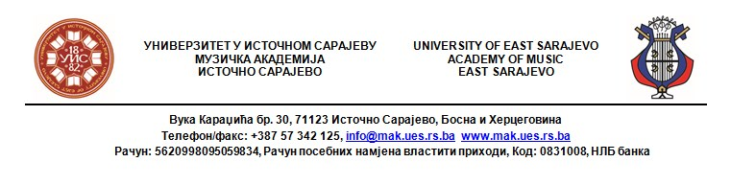

Prijavni obrazac/Application Form
Muzička akademija Univerziteta u Istočnom Sarajevu/Academy of Music,
University of East Sarajevo
Katedra za teorijsku nastavu/Department for Theoretical Teaching
Asocijacija za njegovanje akademske muzike „Novi zvuk“/ Association for the nurturing of academic music "Novi zvuk"

PRIJAVA UČEŠĆA/REGISTRATION OF PARTICIPATION
SEMINAR IZ SOLFEĐA/SEMINAR OF SOLFEGGIO

24- 25. April 2020.

Naziv seminara/The name of the seminar:
Problematika savremene nastave solfeđa /Problems of contemporary solfeggio teaching

Ime i prezime/Name and surname:
Institucija u kojoj ste zaposleni
(puni naziv)/the full name of the Institution where you are employed:
Kojim razredima predajete solfeđo (OMŠ i/ili SMŠ, Muz.akad)/
Which classes do you teach solfeggio (Primary and/or Secondary Music School, Music Academy)
Naziv kvalifikacije i
Nivo kvalifikacijske spreme
(dipl, Bachelor, mr, MA, dr)/ Name of qualification i
Qualification level (Bachelor of Science, MA, MA, PhD)
Institucija u kojoj ste završili visokoškolsko (srednjoškolsko*) muzičko obrazovanje/ The institution where you completed your higher music education (high school *)
Broj mobilnog telefona/ Mobile phone number:
E-mail:
Sugestije za teme i praktičan rad u diskusiji seminara/ Suggestions for topics and practical work in seminar discussion
Prisustvo seminaru: (označiti jedno polje + prvi, drugi ili oba dana)/  Attendance at the seminar:  (mark one box + first, second or both days) | Prvi dan/  First day  24. April 2020. | Drugi dan/  Second day  25. April 2020. | Prvi i drugi dan/  First and second day  24-25. April 2020.
*Ako nemate visokoškolsko muzičko obrazovanje, navedite gdje ste stekli srednjoškolsko muzičko obrazovanje/
* If you do not have a high school music education, please signify where you got your high school music education.

